
Xjenza Online: Science Journal of the Malta Chamber of Scientists
www.xjenza.org
DOI: 10.7423/XJENZA.2022.x.xx

Research Article

A very interesting scientific publication
J. Borg1, J. Doe2∗ and J. Bloggs2
¹Department of Mathematics, Faculty of Science, University of Malta, Malta
²Department of Physics, Harvard University, Cambridge MA, US

Abstract. Xjenza Online is the Science Journal of the Malta Chamber of Scientists and is published in an electronic format. Xjenza Online is a peer-reviewed, open access international journal. The scope of the journal encompasses research articles, original research reports, reviews, short communications and scientific commentaries in the fields of mathematics, statistics, geology, engineering, computer science, social sciences, natural and earth sciences, technological sciences, linguistics, industrial, nanotechnology, biology, chemistry, physics, zoology, medical studies, electronics and all other applied and theoretical aspect of science.
This document template is designed for MS Word users, while those who prefer LaTeX should use the journal's LaTeX template available at Overleaf. To maintain font fidelity, please ensure the Montserrat and Computer Modern Bright fonts are installed as per instructions below. It is crucial that the template's default fonts, font sizes and margins are not modified in any way, as this will minimizes the delays in publishing your paper. Please, also follow carefully the instructions on how to insert references and hyperlinks to your papers.
- Introduction
A manuscript for publication in Xjenza will typically have the following components: Title page, Abstract, Keywords, Abbreviations, Introduction, Materials and Methods, Results, Discussion, Conclusions, Appendices and References. The manuscript will be divided into clearly defined and numbered sections. Each numbered subsection should have a brief heading. Each heading should appear on its own separate line. Subsections should be used as much as possible when cross-referencing text, i.e. refer to the subsection by the section number.
- Title
The title should be concise yet informative. Titles are often used in information-retrieval systems. Avoid abbreviations and formulae where possible.
Author names and affiliations. Indicate the authors’ affiliation addresses (where the actual work was done) below the names. Indicate all affiliations with a lower-case superscript number immediately after each author’s name and in front of the appropriate address. Provide the full postal address of each affiliation, including the country name and, if available, the e-mail address.
Corresponding author. Clearly indicate who will handle correspondence at all stages of refereeing and publication, including post-publication. Ensure that telephone and fax numbers (with country and area code) are provided in addition to the e-mail address and complete postal address. Contact details must be kept up to date by the corresponding author.
Present/permanent address. If an author has changed the address since the work described, this can be indicated as a footnote to the author’s name. The address at which the author actually did the work must be retained as the main, affiliation address. Superscript Arabic numerals are used for such footnotes.
  - Abstract
A concise and factual abstract is required of up to about 250 words. The abstract should state briefly the background and purpose of the research, the principal results and major conclusions. An abstract is often presented separately from the article, so it must be able to stand alone. For this reason, references and non-standard abbreviations should be avoided. If essential, these must be defined at first mention in the abstract itself.
- Fonts
The fonts used in this template are Montserrat and Computer Modern. If you do not have these fonts installed on your computer, you will need to install these by following the instructions below. Note: Word will use a close-matching font if these are not installed on your system. To verify that the font was already installed, check if these are listed in the drop-down font menu. To install the fonts:
- download Computer Modern and Montserrat fonts from: https://www.1001fonts.com/cmu-font.html, and https://www.1001fonts.com/montserrat-font.html respectively.
- Locate the downloaded zip files and extract the files.
- Right-click on the font file and select “Install”. If prompted for permission, click “Yes”.
- Verify that the fonts have been installed by opening Microsoft Word and check that the fonts are listed in the drop-down font menu. Note: if Word was previously opened, you will need to close and re-open it. The Computer Modern font is listed as CMU.
- References and Cross-References
References and citation styles for manuscripts submitted to Xjenza should be in accordance with the APA style of referencing. To include references in your manuscript, you will need to follow these instructions:
- In your word document, go to the “References” tab.
- In the “Citations & Bibliography” group, click on the “Style” dropdown menu and select APA as the citation style.
- Place the cursor where you want to insert the citation.
- Click “Insert Citation” in the “Citations & Bibliography group.
- If you haven’t added any sources yet, click on “Add New Source” and fill in the bibliographic information. Click “Ok” to save the source and insert the citation. For example, (He, 2016).
- To view and manage all your sources, click on “Manage Sources” in the “Citations & Bibliography” group. This will open the “Source Manager” dialog box, where you can edit, delete, or add new sources.
- To insert the bibliography, place the cursor where you want to insert the bibliography, click “Bibliography” in the “Citations & Bibliography” group, and choose “References” from the dropdown menu.
It is highly recommended that you use a reference manager like EndNote, Mendeley or Zotero which have Word plugins to insert citations and manage bibliographies. A general guide would be the following:
- Install the plugin
- Open the reference manager and ensure that your library of sources is up to date.
- Insert the citations from the “References” tab or the tab specific to your reference manager.
- Use the “Insert Citation” button to search for and insert the citation from your reference manager.
- Use the reference manager’s tools to insert the bibliography in your Word document.
The citations need to be linked to their reference for ease of readability. To do so, once the document has been completed:
- Convert the citations to static text from the box around the citation
- Highlight the reference and insert a bookmark by going to “Insert” and “Bookmark”. Enter a unique name for the reference and click “Add”.
- Highlight the citation, right-click and select “Hyperlink”. Choose “Place in this Document” and select the corresponding bookmark. Click “Ok”. The citation will hyperlink to the appropriate reference.

Figures
Figures can be inserted as either single column or two-column images as shown in Figure 1 and Figure 2 respectively. Some considerations when creating your artwork:
- Make sure you use uniform lettering and sizing of your original artwork.
- Save text in illustrations as ‘graphics’ or enclose the font.
- Only use the following fonts in your illustrations: Arial, Courier, Times, Symbol or Computer Modern Roman, the latter is preferred.
- Number the illustrations according to their sequence in the text.
- Name your artwork files as ‘figx’ where x corresponds to the sequence number in your document.
- Provide captions to illustrations separately.
- Produce images near to the desired size of the printed version or greater.
- Make sure that the artwork has no margins and borders.
- Submit each figure as a separate file
To insert an image caption:
- Right click on the figure in the document and select “Insert Caption”.
- Ensure that “Label” is set to “Figure” and in the “Caption” field, type the text you want your caption to read. Figure captions are placed beneath the image.
- Captions should be centered and in CMU Bright font (the same font as the text).
All images should be referenced in text and references should be cross-referenced to the image for ease of readability. To do so,
- Place the cursor where you want to insert the figure reference.
- From “References” select “Cross-reference”
- From the “Reference Type” select “Figure” and from “Insert Reference To” select “Only label and number”. Select the image caption you want to reference and select “OK”.


Figure 1: A cute cat
To insert a larger two-column image, you will first need to change the layout of the page as follows:
- Go to “Layout”, select “Breaks” and “Continuous”
- Place your cursor immediately after the inserted section break.
- Go to the “Layout” tab again and click on “Columns”, then select “One” to make the section a single-column section.
- Insert the image you want to insert and add its caption
- To change the format back to double column, go to “Layout” and insert another continuous break. From layouts, then set the section to two columns.
- If possible, place images that span multiple columns either at the top or at the bottom of the page to disrupt the flow of text as little as possible.
- Tables
Tables should be numbered, captioned and referenced in the same way as figures, with the only difference being that table captions should be placed on top of the table as shown in Table 1. Ensure that the data presented in tables does not duplicate results described elsewhere. Tables should not contain coloured cells and limit the use of vertical lines for clean, professional-looking tables.
- Adding meta data to your document
To improve the searchability of your document, you will need to modify the document’s meta data as follows:

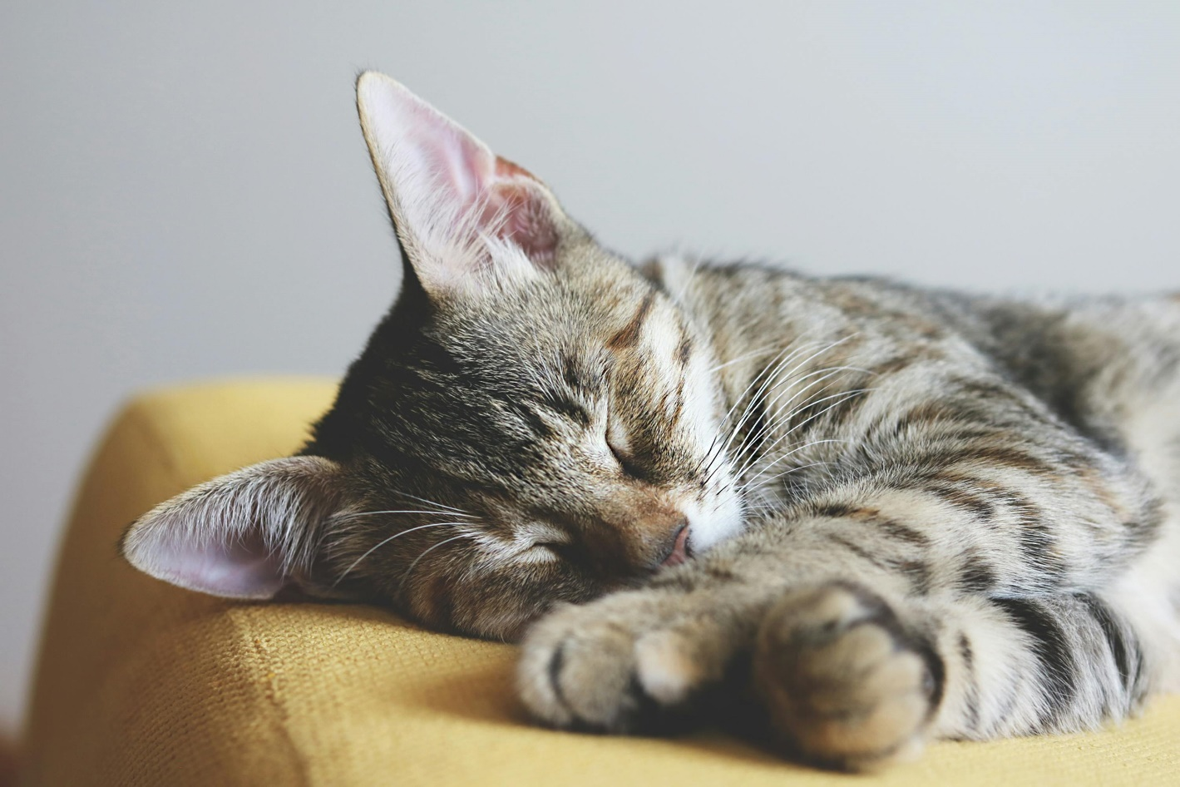
Figure 2: A sleeping cat

Table 1: Fun facts about cats
Fact | Quantity
Average lifespan | 12-15 years
Number of teeth | 30
Jumping height | 5-6 times their body length
Speed | Up to 30mph
Sleeping hours | 13-16 hours per day

- From the “File” tab click on “Info” which will open the document properties on the right side of the window.
- Update the title of the document, include any additional authors, and insert tag (keywords) as necessary.
- Submitting the document
Once your document is finalized, you should export the document as a PDF. You can do this from “File” and “Save As”, selecting the “pdf” from the drop down menu.

References

He, K. Z. (2016). Deep Residual Learning for Image Recognition. Proceedings of the IEEE Conference on Computer Vision and Pattern Recognition (CVPR),, (pp. 770-778).

